SN Bonus report

I have graphs of the 5g and non-conspiracy:
The (5g) graph:
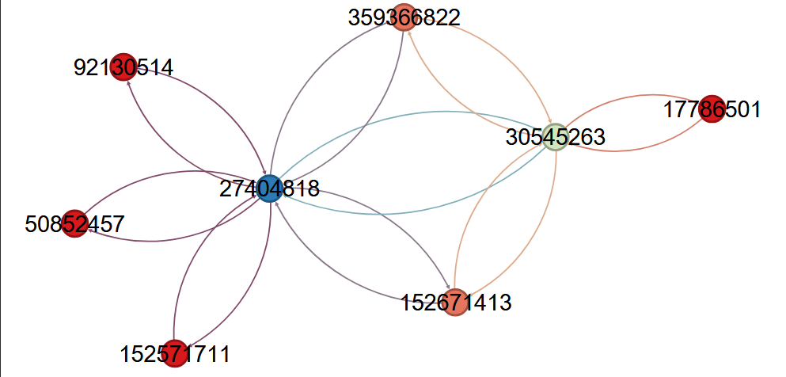

The (non) graph:
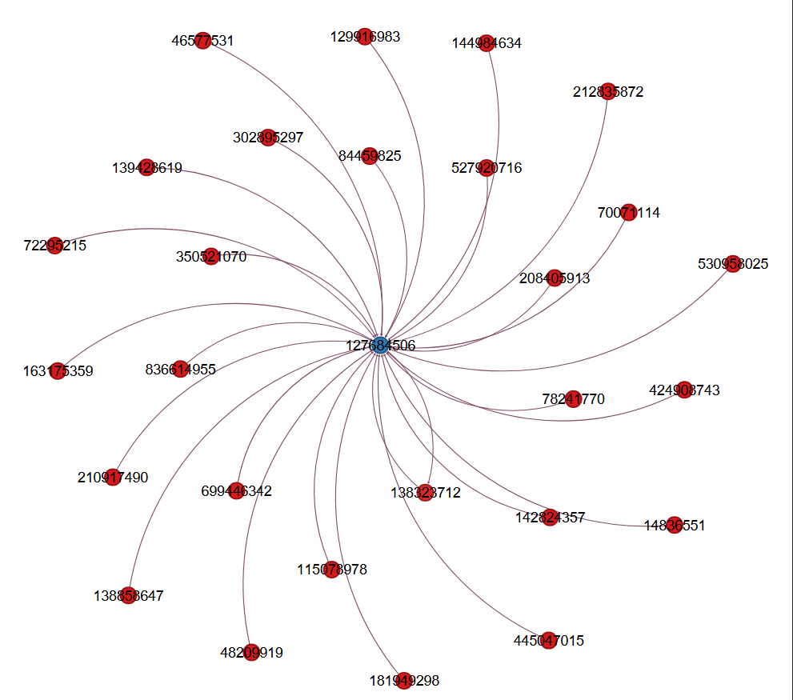

I did every statics in every graph:
- Number of nodes and edges
- Average degree
- Graph density
- Average clustering coefficient
- Modularity (Q) and number of communities
- Betweenness and closeness centrality
- Connected components
Comparison Table: 5G Misinformation vs. Non-Conspiracy Graph:

Metric | 5G (Misinformation) | Non-Conspiracy
Nodes | 8 | 28
Edges | 18 | 28
Average Degree | 2.250 | 1.000
Density | 0.321 | 0.037
Average Clustering Coefficient | 0.308 | 0.000
Modularity | 0.142 | 0.000
Communities | 2 | 1
Top Betweenness Centrality | 3.261905 | 9.071429
Average Betweenness Centrality | 0.833080 | 0.326500
Top Closeness Centrality | 0.875000 | 0.964286
Average Closeness Centrality | 0.577333 | 0.348100
Weakly Connected Components | 1 | 1
Strongly Connected Components | 1 | 27

Average Degree:
1- What it is:
How many connections each node has on average.
2- Why it matters:
Shows how connected users are.
In 5G research:
3-High average degree often means:
- Users interact with more people
- Rumors can spread faster
- Influencers may be dominating the conversation
4-Low degree means:
- People post rarely
- Information does not spread far
______________________________________________________________________________
Density:
1-What it is:
How many edges exist compared to how many could exist.
2-Why it matters:
Density shows how tightly connected the community is.
In 5G research:
High density:
- Very tight group
- Users share a lot with each other
- Strong echo chambers
Low density:
- Slower spread
______________________________________________________________________________
Average Clustering Coefficient
1-What it is:
Measures how much users form triangles or closed groups.
High clustering means:
- People form tight circles
- Echo chambers
- Reinforcement loops
Low clustering means:
- Interactions are spread out
- No tight discussion groups
In 5G research:
Misinformation often forms highly clustered small groups that share and reinforce false information.
______________________________________________________________________________
Modularity & Number of Communities
1-What it is:
tells you how many separate groups (communities) exist inside a network.
It measures how well the network is divided into clusters.
______________________________________________________________________________ Closeness and Betweenness:
Closeness Centrality
What it measures:
How close a user is to everyone else in the network.
Meaning:
A user with high closeness can reach (or spread information to) all other users quickly.

High closeness = fast spreader
Low closeness = slow spreader

Betweenness Centrality
What it measures:
How often a user sits between other users on the shortest path.
Meaning:
A user with high betweenness controls the flow of information between groups.
High betweenness = bridge / gatekeeper
Low betweenness = not controlling paths
______________________________________________________________________________
Connected Components:
A connected component is a group of users that can reach each other through the network.
- 1 component = everyone is connected
- Many components = the network is split into separate, isolated groups
In misinformation:
- Can be tightly connected or split into small groups
In benign networks:
- Usually more isolated users and less connection
______________________________________________________________________________
Most Important Nodes in the 5G Network:
1. Node: 27404818
Why important:
- Top betweenness = 13 (strongest bridge in the network)
- Highest degree = 12 (talks to almost everyone)
- Highest closeness = 0.875 (spreads misinformation the fastest)
- Controls information flow (removing this node breaks the network)
- This is the top important super-spreader.

2. Node: 30545263
Why important:
- Second highest betweenness = 4
- High closeness = 0.70 (spreads fast)
- High degree = 8
- Appears in a different community (modularity class = 1), meaning it may spread misinformation into another group
- This node helps transfer misinformation between communities.

3. Node: 359366822
Why important:
- Closeness = 0.5833 (fairly fast spreader)
- Degree = 4
- Clustering = 1.0 (maximum), forms tight echo chambers, reinforcing misinformation inside a group
- Strong echo chamber builder.

4. Node: 152671413
Why dangerous:
- Closeness = 0.5833
- Degree = 4
- Clustering = 1.0
- Creates strong closed groups that repeat misinformation.

